Queensway Chapel Nursery – November/December 2025 Newsletter
Hello and welcome to our November/December Newsletter.

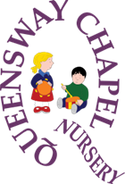
We are looking forward to this term as it is full of festive cheer, bright lights and getting the children ready for the start of Winter. There will be plenty of various exciting activities that the rooms have planned for this term.

Dates for your diary! – November 2025/December 2025/January 2026
Mon | Tue | Wed | Thurs | Fri | Sat | Sun
3 All children back! | 4 | 5 | 6 | 7 | 8 | 9 Remembrance Sunday 
10 | 11Rememberance Day.  All photo proofs back please | 12 Parents evening 5.15-7.15pm | 13 World kindness day | 14 Children In Need Day   | 15 | 16
17 | 18 | 19 | 20 | 21 | 22 | 23
24 | 25 | 26 | 27 | 28 | 29 | 30 St Andrews Day 
1 | 2 | 3 | 4 | 5 | 6 | 7
8 | 9 | 10 | 11 Christmas Jumper day  | 12 Nativity   | 13 | 14 Hanukkah begins  
15 | 16 | 17 | 18 | 19 Children’s Christmas Party. Last day of term | 20 | 21 Winter Solstice
22 Hanukkah ends. All year round children only. | 23 | 24 Nursery closes 12pm. Christmas Eve | 25 Christmas Day   | 26 Boxing Day | 27 | 28
29 | 30 | 31 New year’s eve   | 1 New year’s day   | 2 All year round children only | 3 | 4
5 All children back! | 6 | 7 | 8 | 9 | 10 | 11


What to bring to nursery! Please ensure that your child has a named/ labelled coat and wellies at nursery. We go outside in all weathers. Some spare clothes are also a good idea. This is the time of year when childhood illnesses are more expected. If you feel that your child isn’t well enough to be outside at nursery, then they should stay at home until they are better. We will refuse admission to children who have had Calpol or other paracetamol based medications and we exclude children on antibiotics until they have had at least two doses. This is in line with our sickness and illness policy.

Children in Need – 14th November
We will be raising money this year by dressing up as Pudsey Bear or dressing in something spotty for a donation of £1 – please feel free to donate as much as you want even if your child doesn’t want to dress up, it is all for a good cause!
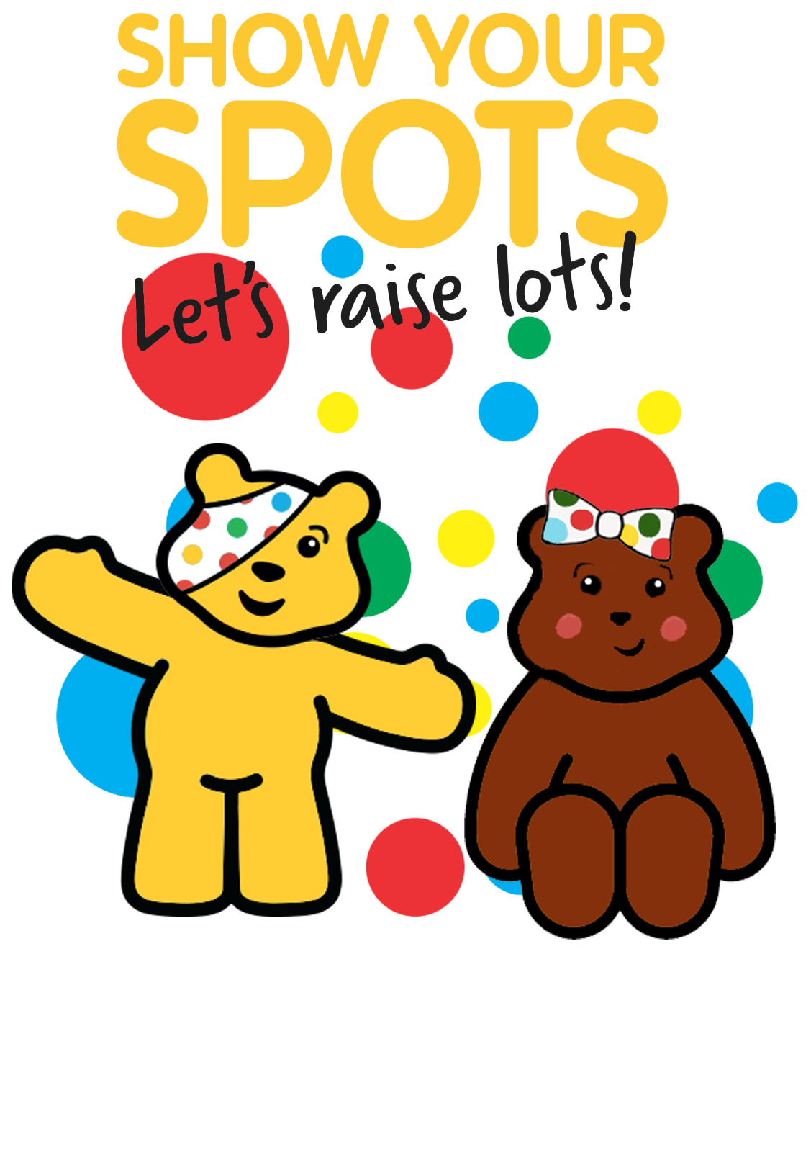
Children’s Christmas party

All children are invited to the Christmas party on 19th December from 5 – 6.30pm. The cost will be £5. Invites will be given out in the next couple of weeks.

Badger Room
We have a new cohort of children that will be accessing the Badger room for Talk Boost, BLAST, Social skills and Maths. Claire who is our SENCO is at hand to help any parents that feel they would like to speak about their child’s development.

Toddler Room
Staff: - Chloe B, Claire L, Robyn and Grace
Welcome back! We hope you all had a fun filled half term.
This term we will be exploring colours in our play and activities and seeing how we can change the colours through mixing and adding different materials. We will also be looking at cause and effect and making volcanos. We have lots of special events happening these next couple of months such as making fireworks pictures and having lots of painting activities to experiment with colours and mark making and talking about bonfire night. We will be making poppy’s to remember all those who were lost. November 13th is World kindness day and we will be talking about being kind and things we can do to make others smile.
The children will also be getting ready for Christmas with all their fantastic decorations and pictures.

Preschool Room
Staff: Beth – Deputy Manager and Room Leader, Laura – Deputy Room Leader, Ayesha, Claire T, Lauren, Sue, Chloe C
Welcome back to term 2, our favourite term of the year full of glitter, smiles and lots of singing! We have a busy but exciting term ahead with so much to look forward to, including our Nursery Nativity. The nativity will be displayed at the Chapel on Friday the 12th of December at 6pm - invites to follow very soon. The Nativity is always such a lovely evening and a chance to celebrate all of the hard work the children have put into the play, so we hope to see you all there. But first we have bonfire night which takes places on Wednesday the 5th of November, throughout the week at Nursery the children will be making some fabulous firework pictures and on Wednesday the 5th of November we will be toasting marshmallows over the fire and enjoying hot chocolate. As we approach Christmas, the children will be busy making lots of festive decorations to bring home so please excuse the glittery hands and faces as they leave the door! We will also be recreating our very own “Polar Express" train at Nursery for the children to experience. We can't wait for the next few fun filled weeks!

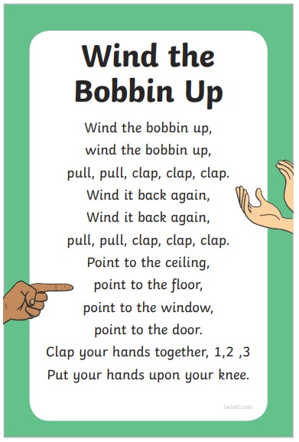
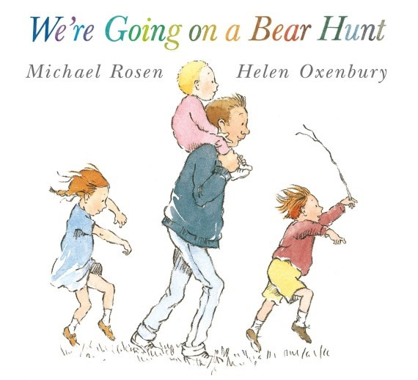
Termly song and story
“Research has found that when a child knows eight or more nursery rhymes by heart, at the age of 4, that they are usually one of the best at reading and spelling in their class by the age of 8!” https://www.littlesignersclub.co.uk/ten-reasons-sing-nursery-rhymes-babies/
We know that rhymes and songs play such a crucial part in early learning and development that we will now have a termly song which we will share with you! This terms song is Wind the Bobbin up! We will also be introducing a termly story which will link in with some of our planned activities and experiences for the children. This term the story is “We’re going on a Bear Hunt!” By Michael Rosen. Keep an eye out on Tapestry for learning idea’s that you can try out at home to support play and learning at nursery!

